

*Capable People, Capable Communities*

**Micro-Credentials in Software Development**

**Certificate in Software Development**

**MCSD51**

**Project Design**

**MISUN HWANG**

**September 2022**

Contents

**Introduction** 3

**Scope** 3

**User stories and use cases** 3

**Ethical and cultural impact** 5

**SDLC** 5

**Project timeline** 5

**Diagrams** 6

**User Interface Definition** 6

**User Interface FlOW (by figma)** 20

**Database ER diagram (by lucid)** 21

**Sequence diagram** 21

**References** 28

# Introduction

It is very difficult for people with little work experience trying to write a CV for a new job. But even those who have too much work experience struggle to choose work experience by role to apply for a new job. This is because they have to reselect detailed career for each role they want to apply for, rewrite a CV, and write a new cover letter that fits that role. Occasionally they miss an opportunity because they cannot submit their application right away when they need it. In this project, I propose to build a web application that automatically generates CVs and cover letters based on the role which users are applying for. The system allows users to view job-specific CVs and cover letters and download them as standardized documents. The target users of this system are job seekers with experience in various fields.

# Scope

The ultimate goal of this project is to log in for each person, register their career information, filter career information by role, view CV and Cover Letter on the screen, and download it as a file or send it by email. However, given the short project period of 4 weeks, in this project, I want to implement a system for one user, and will contain only 3 essential functions. These are the adding page of each career information, the view page that shows the CV composed of only those items by filtering the career details according to the role entered, and the page that maps to the existing career details when adding a new role. However, for future functional expansion, designing a database will be considered for multiple users.

# User stories and use cases

**User Stories**

As a job seeker, I need to store my career information whenever I perform tasks as a new role, so that I can manage my work experience systematically.

As a job seeker, I want to view my job experience regarding to a specific role with a standard CV format, so that I can reduce the preparation time for a job and quickly submit my application.

As a job seeker, I want to download my customized CV, so that I can reduce the preparation time for a job and quickly submit my application.

As a job seeker, I want to view my cover letter, which is generated automatically, regarding to a specific role, so that I can reduce the preparation time for a job and quickly submit my application.

As a job seeker, I want to download my customized cover letter, so that I can reduce the preparation time for a job and quickly submit my application.

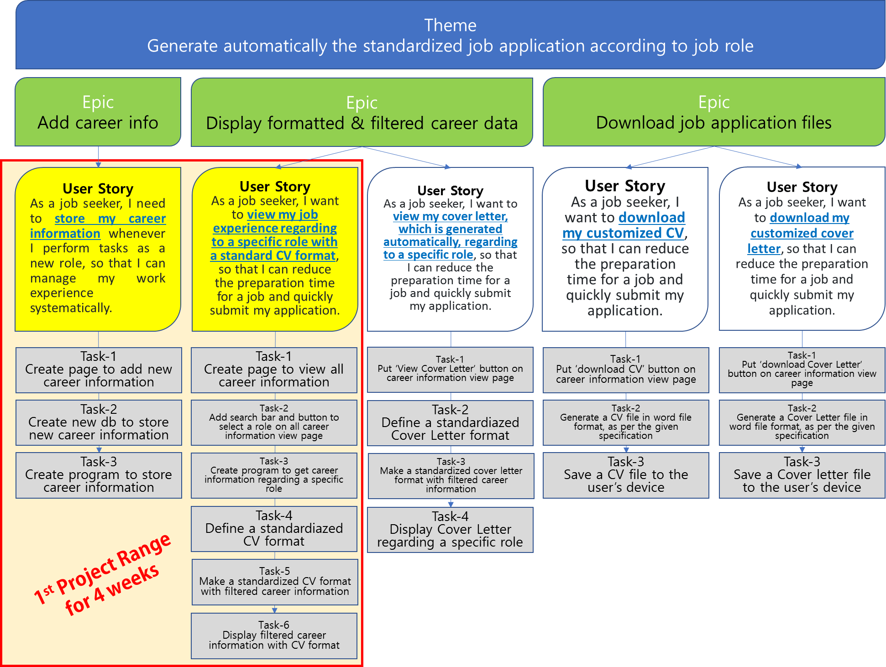

**Use Cases for 1st Project Range**

**Actor**

The system is for job seekers. So, all activity will be operated by them. So ‘a Job Seeker’ is a primary actor for this system. However, this system should have a predefined CV format to generate it when user requests. So ‘System’ becomes a supporting actor.

**Use Case**

|  |  |  |
| --- | --- | --- |
| **Use Case** | **Description** | **Related User Story** |
| Add personal information | A job seeker adds personal information for CV header | As a job seeker, I need to store my career information whenever I perform tasks as a new role, so that I can manage my work experience systematically. |
| Add new career | A job seeker adds a new job experience |
| Add new role | A job seeker adds new role title |
| Assign role to career | A job seeker maps their career to roles |
| View all career history | A job seeker views his/her all job experience | As a job seeker, I want to view my job experience regarding to a specific role with a standard CV format, so that I can reduce the preparation time for a job and quickly submit my application. |
| Search for career regarding filtered role | A job seeker searches limited work history about a specific role |
| Generate and display CV having filtered career | System generates formatted CV data and display it according to the searching event. |
| Print out the screen | A job seeker prints out the search results having formatted career information |
| Define CV format | System stores a display format |

# Ethical and cultural impact

This system is composed of personal career information and it should be secure carefully. So, all input information will be safely stored and managed in a database to prevent unauthorized leakage of the user's information. In addition, it will be designed as a user-based system so that no one other than the user can modify the information.

For avoiding discriminable aspect of society, this system does not ask personal information such as gender, age, religion, ethnicity.

# SDLC

I chose to use the Waterfall software development methodology for 1st Project range. Because the requirements are clearly stated in the beginning. Also, since the project must be completed within a short project period, multiple reviews and iterative development cannot be allowed. Instead, I will include the contents so that all requirements for each development stage can be reflected. Other than that, the waterfall methodology lets me know where my project is and where it should be at any given time thanks to its sequential methodology.

# Project timeline

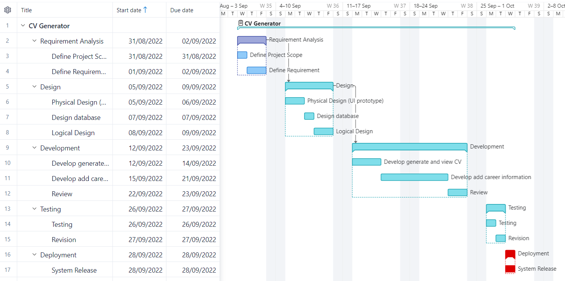

# Diagrams

**Use Case Diagram**

# User Interface Definition

|  |  |  |
| --- | --- | --- |
| **User Interface** | **Description** | **Related Use Case** |
| Main | Entry page |  |
| View Personal Information | View personal information including name, phone number, email, linkedin URL, CV objective | Add Personal Information |
| Edit Personal Informatin | Edit personal information : phone number, email, linkedin URL, CV objective | Add Personal Information |
| Add Career | Add new career information : main role title, employment type, company name, country, work date, description, detail 1, detail 2, skills, sub roles | Add new career |
| Edit Career | Edit career information : main role title, employment type, company name, country, work date, description, detail 1, detail 2, skills, sub roles | Add new career |
| Add Education | Add new education information : school name, country, course name, degree, study date, grade, special things | Add new career |
| Edit Education | Edit education information : school name, country, course name, degree, study date, grade, special things | Add new career |
| Add Certification | Add new education information : school name, country, course name, degree, study date, grade, special things | Add new career |
| Edit Certification | Edit education information : school name, country, course name, degree, study date, grade, special things | Add new career |
| Add Role | Add new role name | Add new role |
| Map Role to Career | Map role name to career which is existing already | Assign role to career |
| View My All Career | View all career history and education history | View all career history |
| View Tailored Career | View tailored career history for a specific role | Search for career regarding filtered role |
| Preview CV | Generate tailored CV data on screen for a specific role | Generate and display CV having filtered career |

**Main**

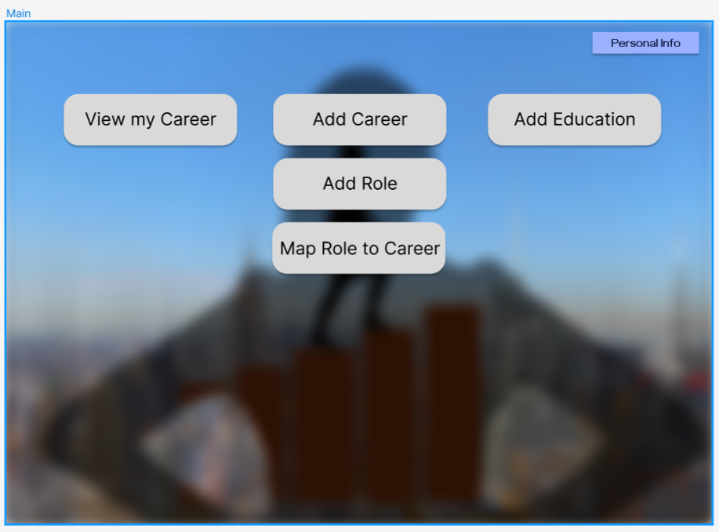

Main page is a gate to connect to major function.

* [Personal Info] link : Connect the view page for personal information
* [View my Career] link : Connect the view page for all career history
* [Add Career] link : Connect the page to add new career information
* [Add Role] link : Connect the popup page to add new role title
* [Map Role to Career] link : Connect the mapping page between a specific role and careers
* [Add Education] link : Connect the page to add new education information

**View Personal Information**

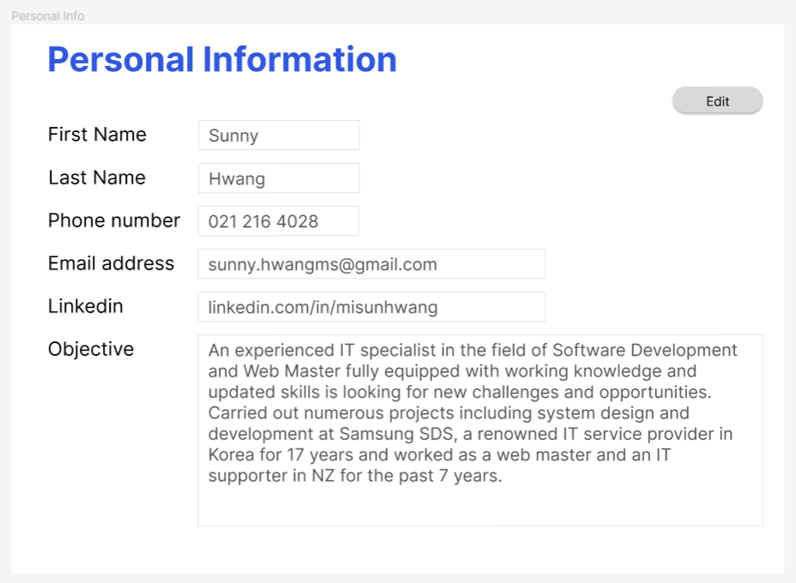

Users view their personal information to show to their CV.

The detail information consists of first name, last name, phone number, email address, linkedin URL, CV objective. This page has user id ‘sunny’ implicitly. UserID is a unique key for each user and it will be used for the future.

Users can connect to the editing page for personal information from this page by clicking [Edit] button.

**Edit Personal Information**

Users edit their personal information to show to their CV.

User can edit their phone number, email address, linkedin URL, CV objective except first name and last name. This page has user id ‘sunny’ implicitly. UserID is a unique key for each user and it will be used for the future.

* [Save] button : All changed information is updated into database tables with unique key, ‘userID’ . And then, ‘Edit’ page returned to ‘View’ page for personal information.
* [Cancel] button : All changed information is ignored. And then, ‘Edit’ page returned to ‘View’ page for personal information without any data’s change.

**Add Career**

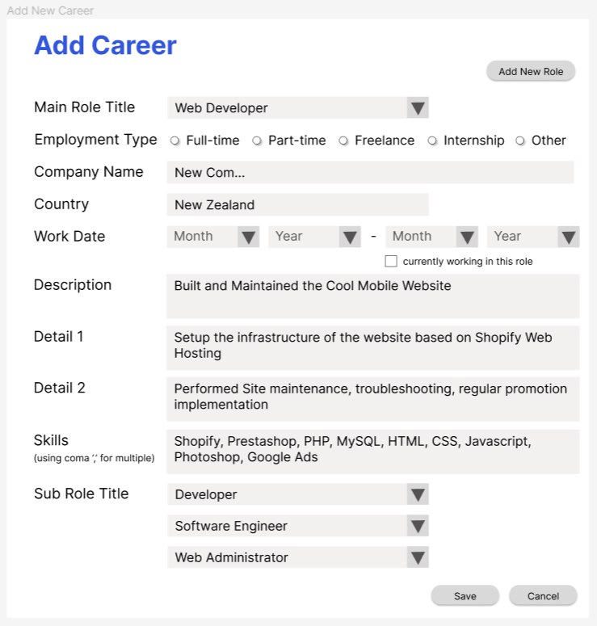

Users add their new job experience.

Users input the detail job information such as main role title, sub roles, employment type, company name, country, start and end date, main job description and up to two detail descriptions, skills. If job is not finished, users check ‘currently working in this role’.

User can edit their phone number, email address, linkedin URL, CV objective except first name and last name. This page has user id ‘sunny’ implicitly. UserID is a unique key for each user and it will be used for the future.

* [Save] button : All new job information is stored into database tables with unique generated key, ‘jobID’. And then, ‘Add career’ page returned to ‘Main’ page.
* [Cancel] button : All input data is ignored. And then, ‘Add career’ page returned to ‘Main’ page.
* [Add New Role] button : Connect the popup page to add new role title

**Edit Career**

Users edit their career information.

User can edit all detail career information except ‘JobID’. JobID is a unique key for each user’s career.

* [Save] button : All changed information is updated into database tables with unique key, ‘jobID’ . And then, ‘Edit’ page returned to ‘View’ page for career information.
* [Cancel] button : All changed information is ignored. And then, ‘Edit’ page returned to ‘View’ page for career information without any data’s change.

**Add Education**

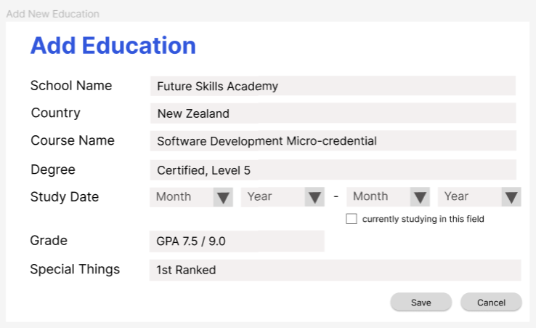

Users add their new educated experience.

Users input the detail educated information such as school name, country, course name, degree, study date, grade, special comment. If education is not finished, users check ‘currently studying in this field’.

* [Save] button : All new educated information is stored into database tables with unique generated key, ‘educationID’. And then, ‘Add education’ page returned to ‘Main’ page.
* [Cancel] button : All input data is ignored. And then, ‘Add education’ page returned to ‘Main’ page.

**Edit Education**

Users edit their education information.

User can edit all detail education information except ‘educationID’. educationID is a unique key for each user’s education.

* [Save] button : All changed information is updated into database tables with unique key, ‘educationID’ . And then, ‘Edit’ page returned to ‘View’ page for career history.
* [Cancel] button : All changed information is ignored. And then, ‘Edit’ page returned to ‘View’ page for career history without any data’s change.

**Add Certification**

Users add their new certification.

Users input the detail certification information such as certification name, issued organization, issue date, description.

* [Save] button : All new certification information is stored into database tables with unique generated key, ‘certificationID’. And then, ‘Add certification’ page returned to ‘Main’ page.
* [Cancel] button : All input data is ignored. And then, ‘Add certification’ page returned to ‘Main’ page.

**Edit Certification**

Users edit their certification information.

User can edit all detail certification information except ‘certificationID’. certificationID is a unique key for each user’s certification.

* [Save] button : All changed information is updated into database tables with unique key, ‘certificationID’ . And then, ‘Edit’ page returned to ‘View’ page for career history.
* [Cancel] button : All changed information is ignored. And then, ‘Edit’ page returned to ‘View’ page for career history without any data’s change.

**Add Role**

Users can add new role title if they don’t find a proper role from a role list. New role name is shown to all users.

* [Save] button : New role name is stored into database table. And then, ‘Add role’ popup page is closed.
* [Cancel] button : All input data is ignored. And then, ‘Add role’ popup page is closed.

**Map Role to Career**

Users assign a specific role to the existing careers multiply. This page consists of role list and career history with a check box. Users select a specific role from the roles combo box, and then select the careers to want to assign to the role.

* [Save] button : New relationships between a role and careers are stored into database tables. If users deselect the career, the relationship between a role and the deselected careers are deleted from tables. Finally, ‘Map role to career’ page is returned to ‘Main’ page.
* [Cancel] button : All input data is ignored. And then, ‘Map role to career’ page is returned to ‘Main’ page.

**View My All Career**

Users view their all career histories. This page consists of role combo box, career histories, certification histories, education histories. Users can edit or delete their career, certificate, and education information on this page. User can view the tailored histories by selecting a specific role and preview the tailored data with CV format without any specific role.

* [Search] button : Get the filtered career histories related to the selected role.
* [Preview CV] button : Page is displayed with CV format without any specific role
* [Edit] for career : Connect to edit a specific job career
* [Delete] for career : Delete a specific job career
* [Edit] for education : Connect to edit a specific education information
* [Delete] for education : Delete a specific education information
* [Edit] for certification : Connect to edit a specific certification information
* [Delete] for certification : Delete a specific certification information

**View Tailored Career**

Users view the tailored career histories related to the selected role. This page consists of role combo box, career histories, certification histories, education histories. Users can edit or delete their career, certificate, and education information on this page. User can preview the tailored data with CV format.

* [Search] button : Get the filtered career histories related to the selected role.
* [Preview CV] button : Page is displayed with CV format
* [Edit] for career : Connect to edit a specific job career
* [Delete] for career : Delete a specific job career
* [Edit] for education : Connect to edit a specific education information
* [Delete] for education : Delete a specific education information
* [Edit] for certification : Connect to edit a specific certification information
* [Delete] for certification : Delete a specific certification information

**Preview CV**

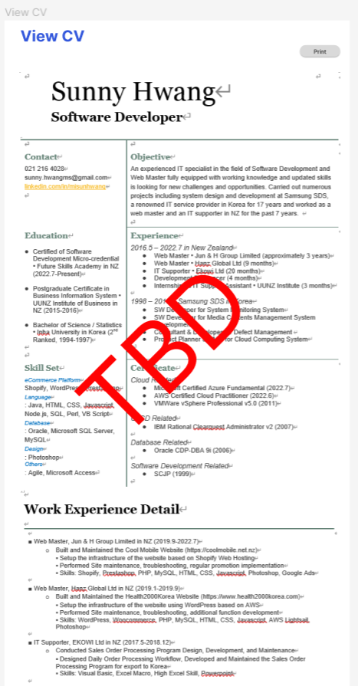

Users view their tailored CV formatted data for a specific role. Users can print this page.

# User Interface FlOW (by figma)

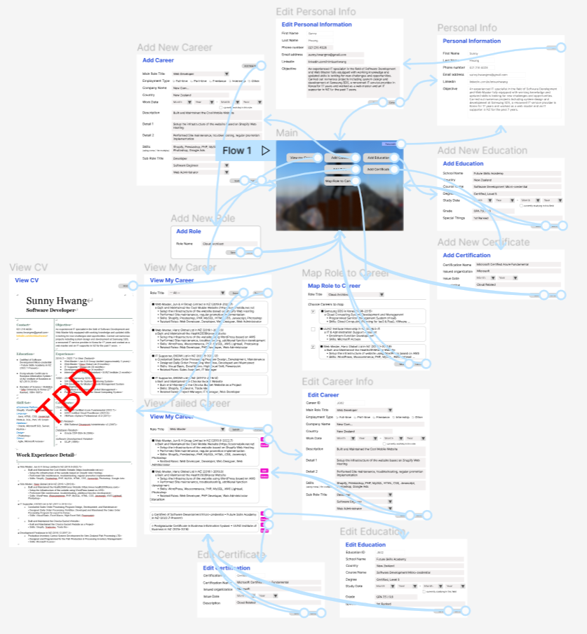

[https://www.figma.com/file/ZQzamMUUVJg07fHlvDbFnW/Untitled?node-id=0%3A1]

# Database ER diagram (by lucid)

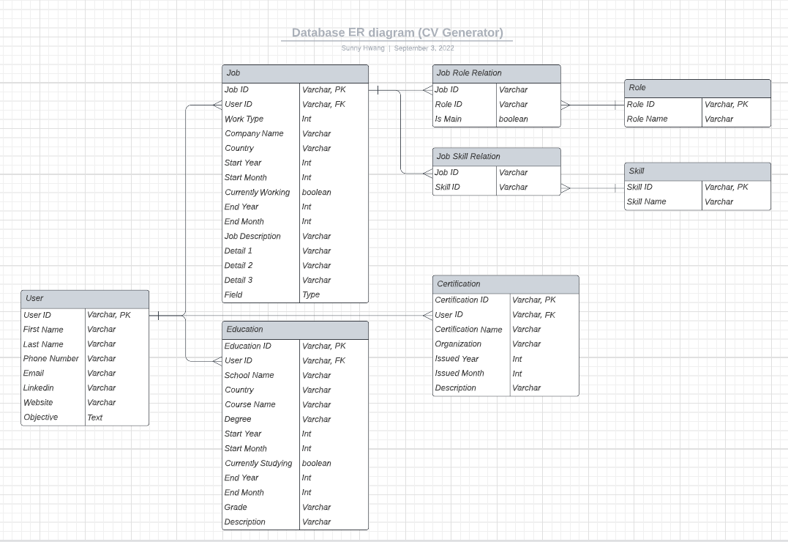

# Sequence diagram

**View Personal Information**

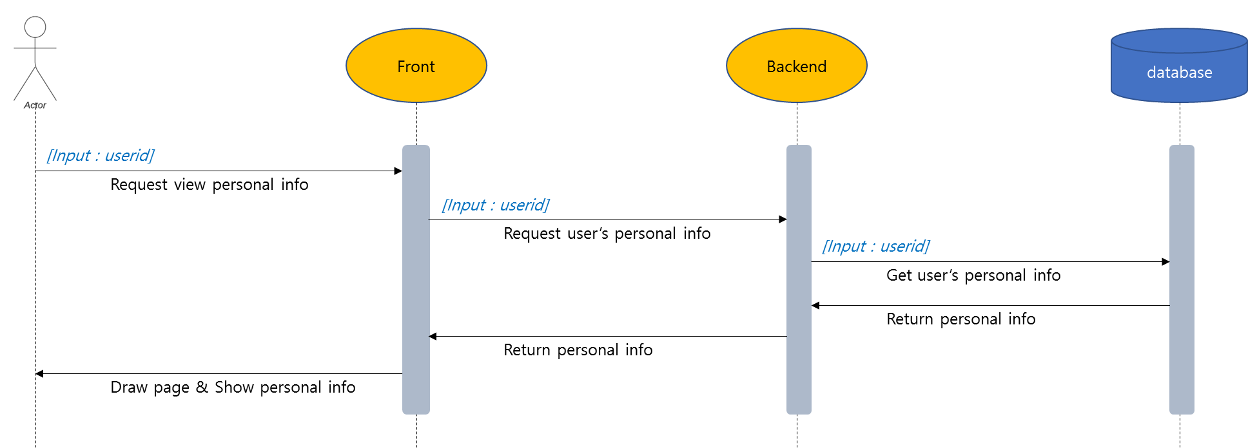

**Edit Personal Information**

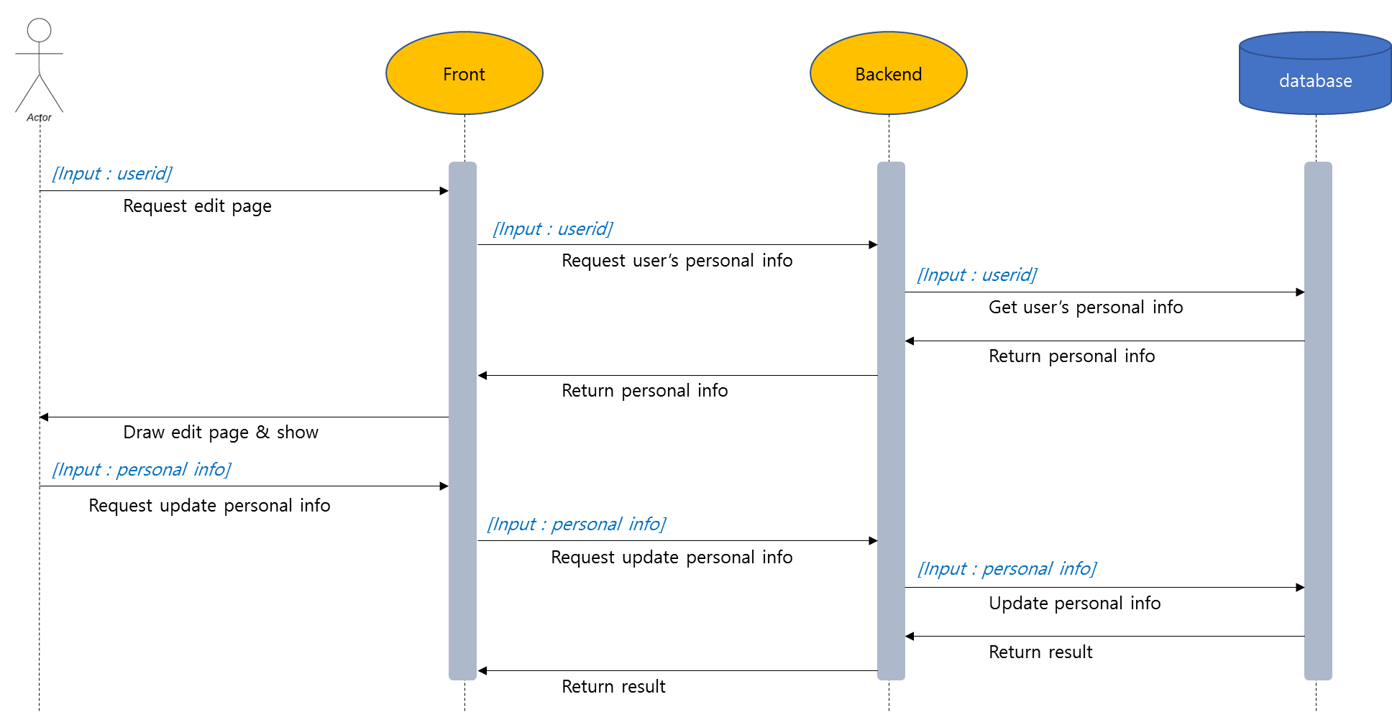

**Add Career**

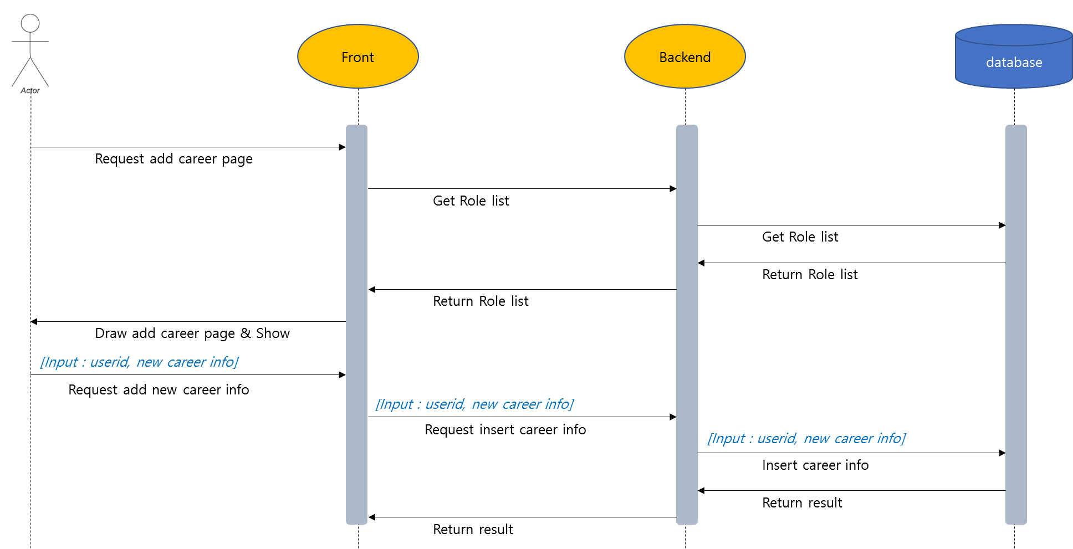

**Edit Career**

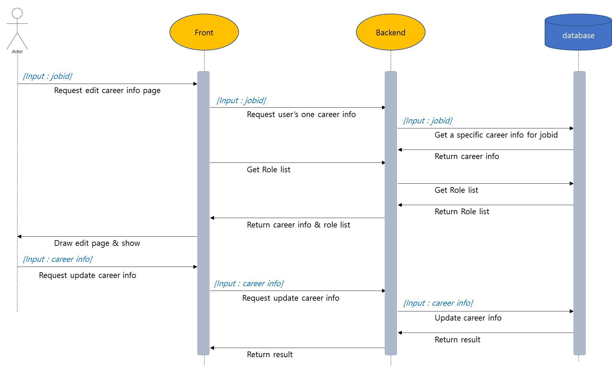

**Add Education**

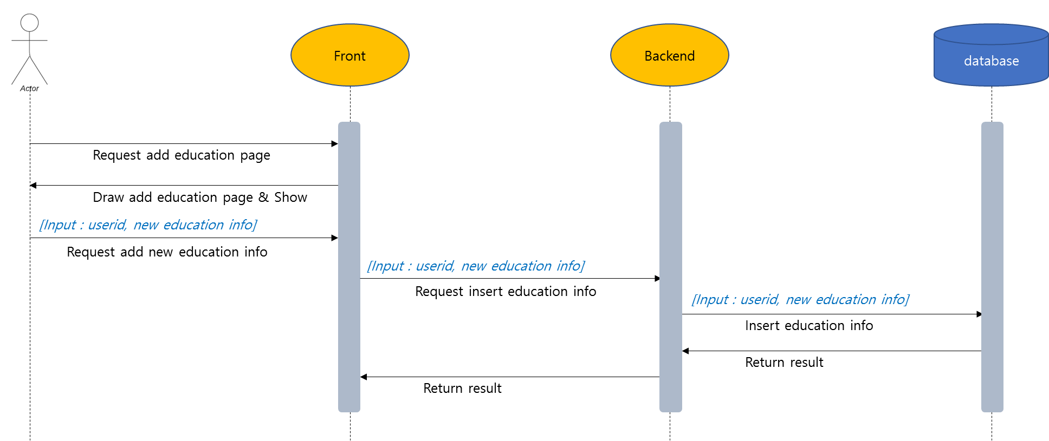

**Edit Education**

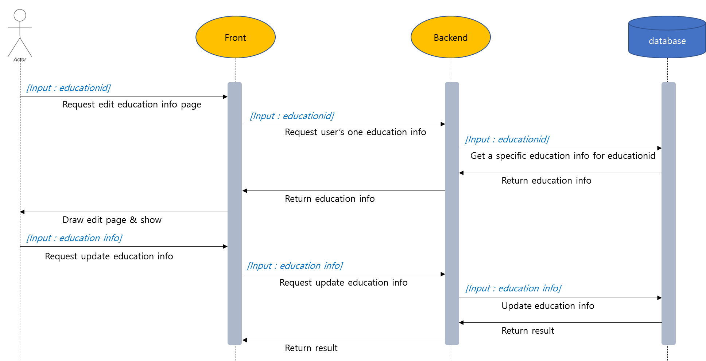

**Add Certification**

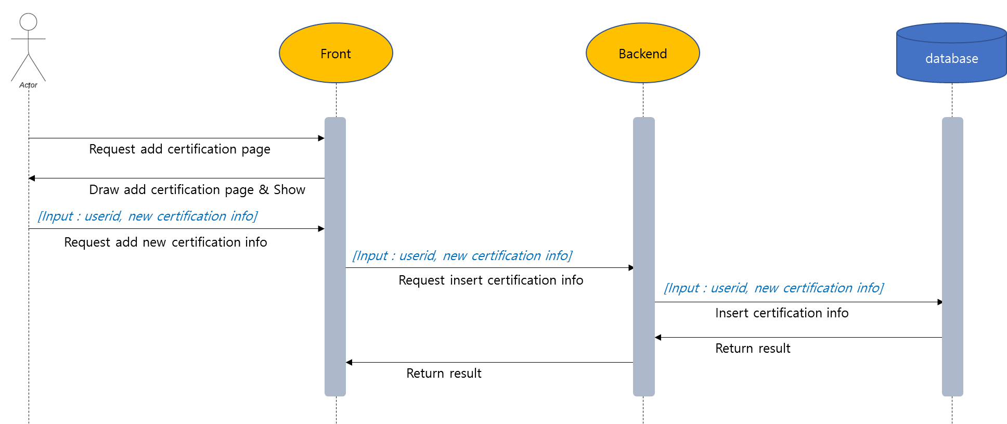

**Edit Certification**

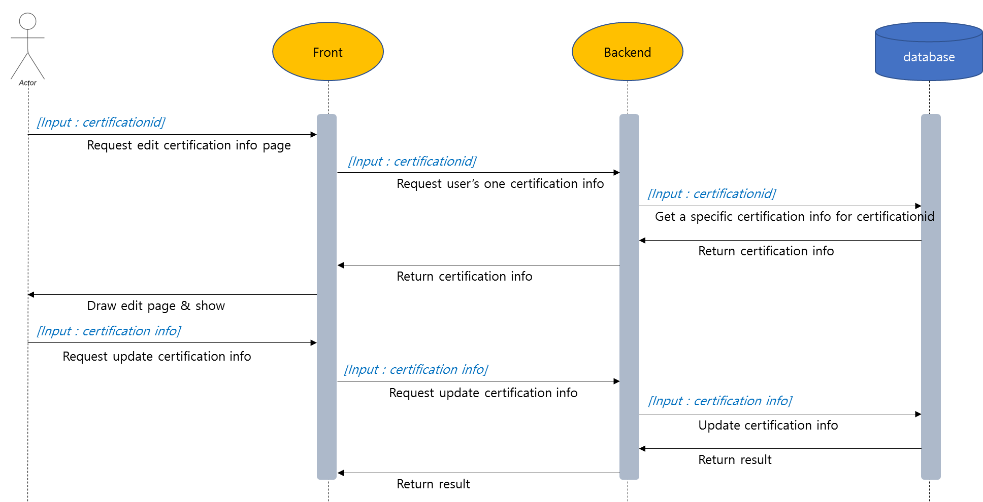

**Add Role**

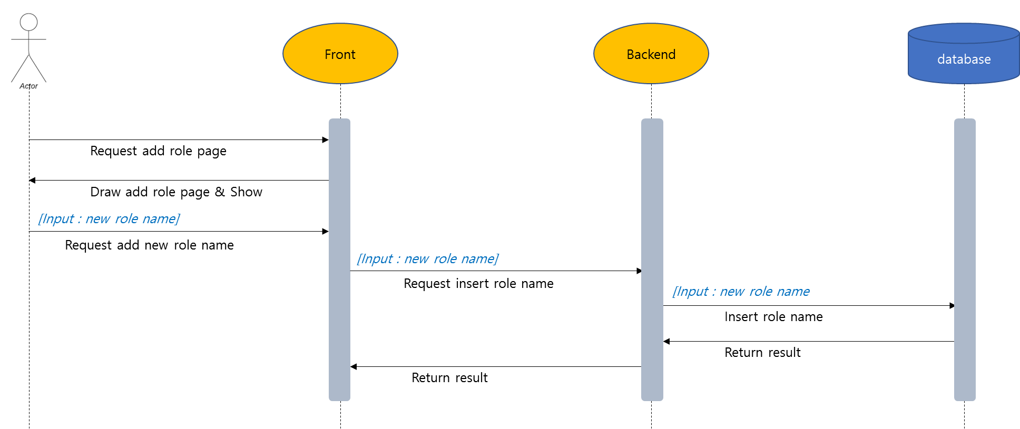

**Map Role to Career**

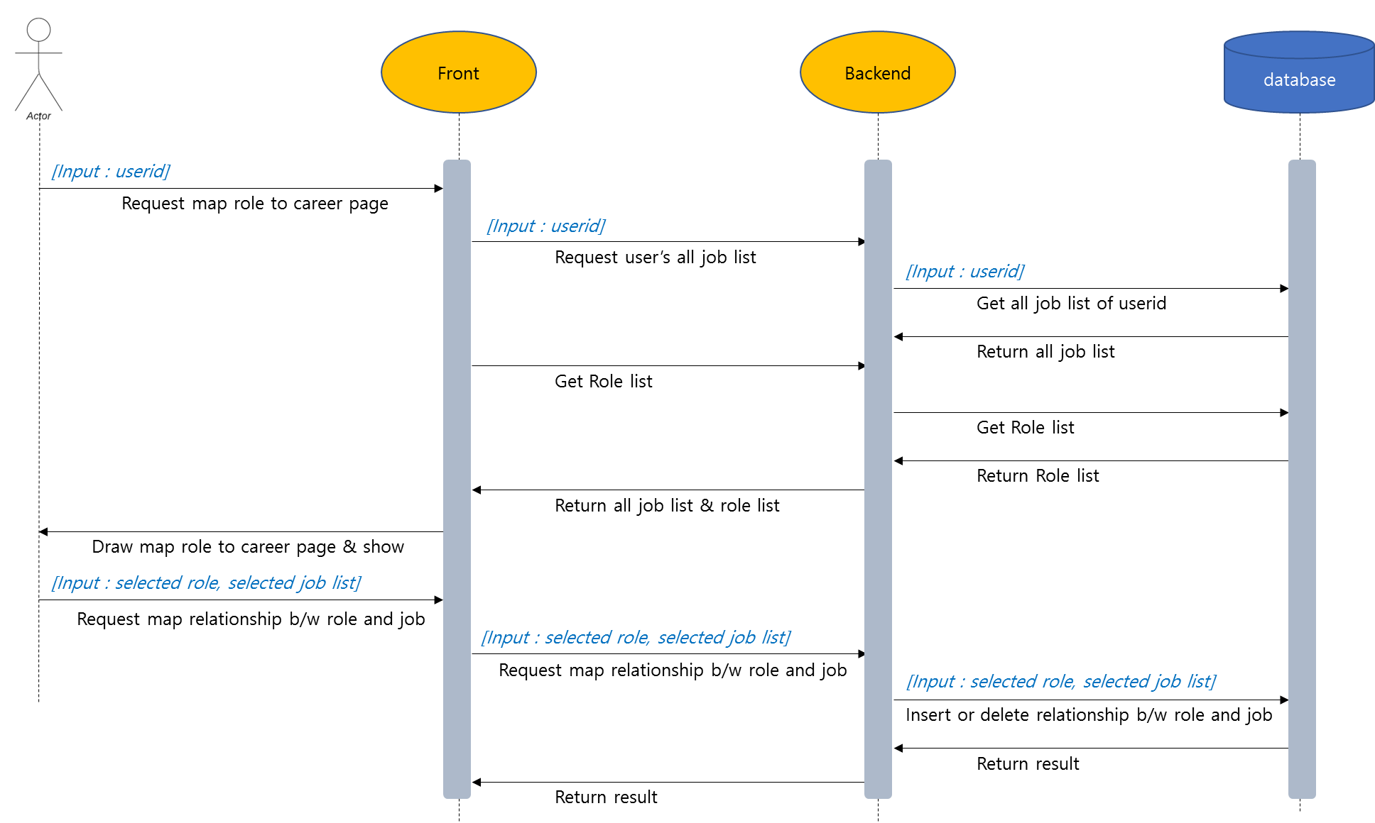

**View My All Career**

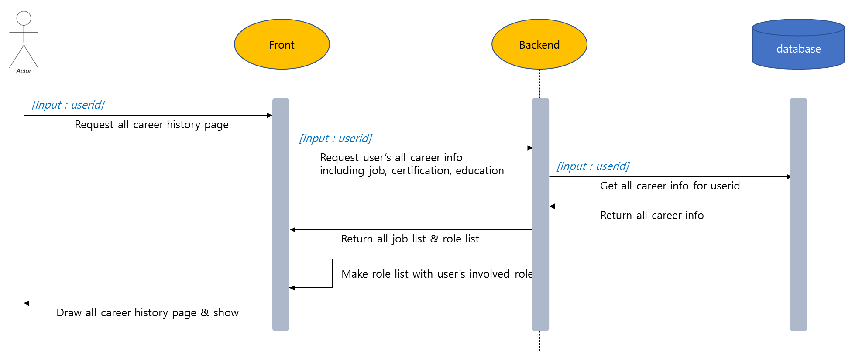

**View Tailored Career**

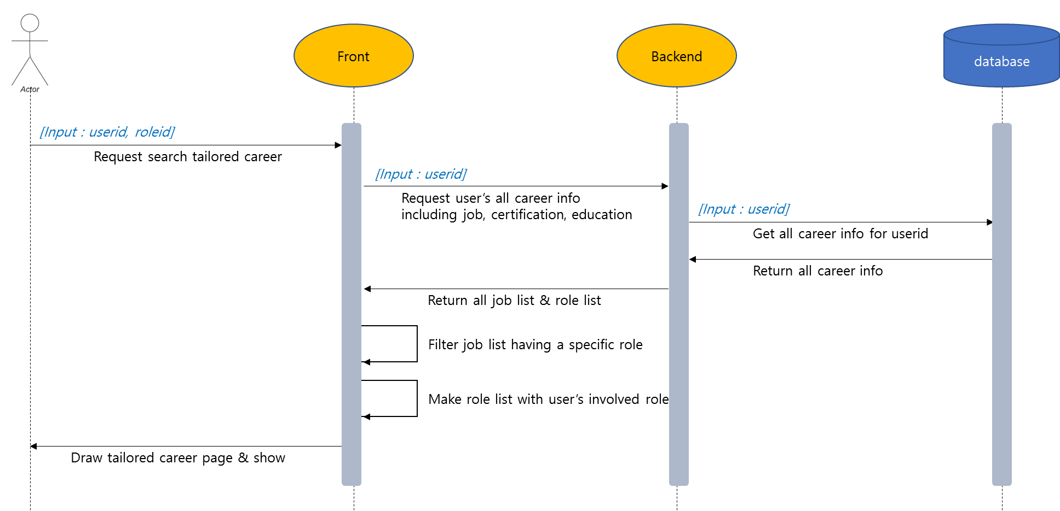

**Preview CV**

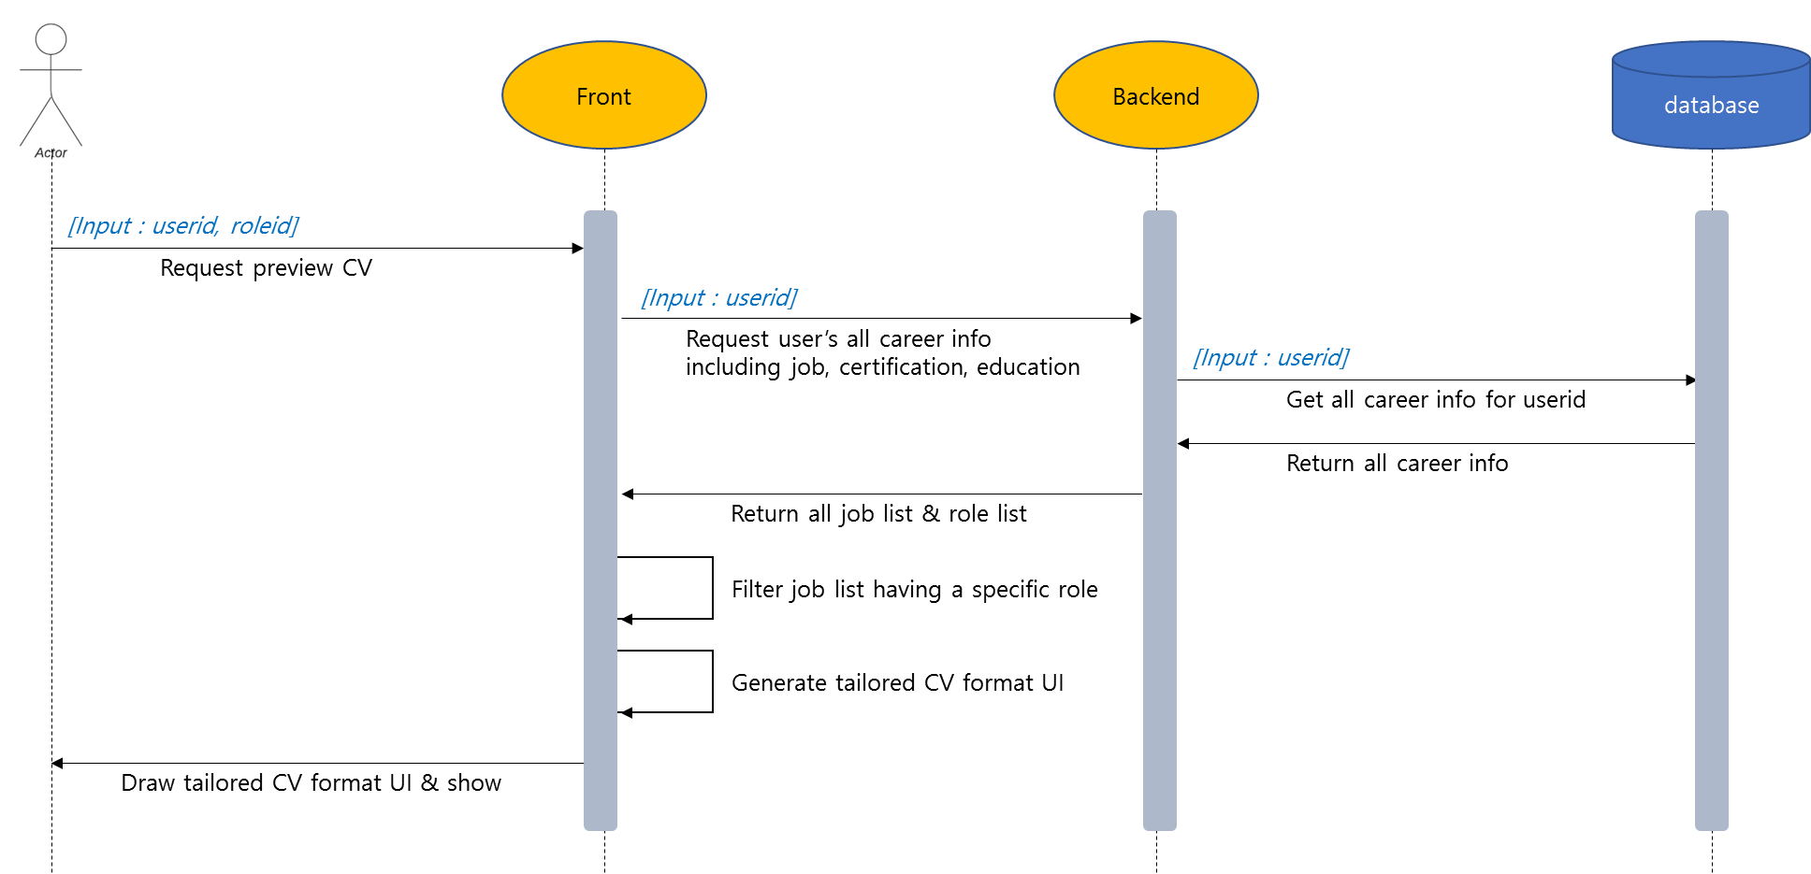

# References

Bobert Half (2021), *6 Basic SDLC Methodologies: Which One is Best?*, https://www.roberthalf.com/blog/salaries-and-skills/6-basic-sdlc-methodologies-which-one-is-best

George Lawton (2020), *5 examples of ethical issues in software development*, https://www.techtarget.com/searchsoftwarequality/tip/5-examples-of-ethical-issues-in-software-development

Lucid Content Team (?), *What the Waterfall Project Management Methodology Can (and Can’t) Do for You*, https://www.lucidchart.com/blog/waterfall-project-management-methodology